Depreciation For civil 7th, computer7th and Civil 4th
Meaning of depreciation
A non-cash expense that reduces the value of an asset as a result of wear and tear, age, or obsolescence is called depreciation. Most assets lose their value over time (in other words, they depreciate), and must be replaced once the end of their useful life is reached. There are several accounting methods that are used in order to write off an asset's depreciation cost over the period of its useful life. Because it is a non-cash expense, depreciation lowers the company's reported earnings.
Depreciation is the permanent and gradual decreases in the value of an asset from any cause.
The objectives of computing depreciation are to (1) reflect reduction in the book value of the asset due to obsolescence or wear and tear, (2) spread a large expenditure (purchase price of the asset) proportionately over a fixed period to match revenue received from it, and (3) reduce the taxable by charging the amount of depreciation against the company's total income. In effect, charging of depreciation means the recovery of invested capital, by gradual sale of the asset over the years during which output or services are received from it. Depreciation is computed at the end of an accounting period (usually a year), using a method best suited to the particular asset.
Different types of assets are being used by business concern for facilitating trading activities and some assets have been used in the business to derive benefits for more than one accounting period, such assets are called fixed assets like plant and machinery, buildings, equipments, furniture, vehicles etc. these fixed assets have a limited life and on the process of use the value of such assets would decline with passage of time. Hence, the reduction in value of such capital asset is technically known as depreciation. In short, depreciation is loss in value of capital goods due to wear and tear, ageing or obsolescence. The value of capital goods is assumed to decrease each for the accounting purpose.
- Depreciation is a gradual decrease in the value of fixed assets.
- It is treated as a non-cash expense or loss.
- The gradual diminution in the utility value of an asset due to wear and tear or from any other reasons.
- It aims at distributing the net cost of tangible asset over the estimated useful life of the asset.
- It is a process of allocation not of valuation.
Causes of depreciation
Depreciation is caused due to the following reasons:
- Wear and tear: the continuous use of an asset makes it old and degrease in working capacity and hence the value of asset depreciates.
- Effusion of time: with the passage of time, the value of some assets diminishes, even if they are not used in the business.
- Obsolescence: an existing asset may loss its usefulness due to an improvement in technology, new invention, chance in style etc. it is also called functional or technological depreciation.
- Exhaustion or depletion: an asset may get exhausted through working. It applies to mines and quarries.
- Accident: due to accident it also may cause depreciation in assets. Such accidental causes may be natural disasters or manmade disasters.
- Fall in market value: the value of an asset may decrease due to call in market price of the assets.
Advantages of providing depreciation
Depreciation is essential due to following reasons:
- Ascertainment of cost of production: it is necessary to charge depreciation as an item of cost for showing a true and fair view of the cost of production. In the absence of depreciation, the production cost appears to be lower than the actual cost.
- Correct ascertainment of net profit or loss: depreciations also an expenditure item as wages rent, salary etc. therefore, it must be charged for the correct picture of profit and loss.
- Replacement of assets: depreciation is non-cash expenses. It is retained in the business and used for the replacement of fixed asset at the end of this useful life because the new asset can be purchased with the accumulated depreciation funds.
- To keep capital safe: if depreciation is not charged, the profit shown by the profit and loss account will be in excess of actual profit and it is distributed among the owners. As such, the amount of depreciation is actually a part of capital asset and to keep capital safe, depreciation deduction is most essential.
- For correct ascertainment of income tax: if depreciation is not charged, the profit and loss account will show more profit and the firm will have to pay more income tax on the profit. Hence, the depreciation is charged for the correct assessment of income tax.
- Fair financial position: it is necessary to charge depreciation for preparing a true and fair value of fixed assets in the balance sheet. If the depreciation is not charged, the assets will be shown at a value more than its actual value.
Factor affecting the amount of depreciation
The amount of depreciation is based on the following factors:
- Total cost of asset: total cost is taken as a main basis for deterring the rate and amount of depreciation. It includes the invoice cost plus all other cost like transportation, installation, insurance, import tax etc.
- Estimated useful service life: the expected period of time to sue the asset is earning process is termed as useful service life. It is also taken as a a\basis for the determination of the amount of depreciation. The service life may be measured in terms of time, unit of output, working hours etc.
- Estimated salvage value: the expected value to be realized on the expiry of an asset is termed as salvage value. It should be determined for correct ascertainment of depreciation.
- Estimated expenditure for repair: for the excellent operation of the asset, time to time repair is very important which increases life of asset to some extent. Such spatial expenditure on repairs should also be considered while determining depreciation rate of amount.
- Legal provision: legal provisions should be considered with regard to depreciation because the rate and method of depreciation must be subject to statutory provision.
Depreciation methods
There are several methods of depreciation. The selection of method for providing deprecation depends upon types of assets, nature of assets use, management policy, legal provisions etc. some important methods of depreciation are follows:
- Straight line method
- Matheson method
- Sinking fund method
- Sum of year digit method
- Double line declining method
- Service output method. / Units of production methods
- Modified accelerated cost recovery system. MACRS

- Straight line method
It is the simplest method for charging depreciation. It is also known as fixed installment method. Under this method, the same or equal or fixed amount of depreciation is charged every year throughout the life of the assets so that the book value of asset may be reduced to zero. It is calculated by considering original cost, useful life, salvage value of the asset. This method is suitable for those assets whose working life can be easily estimates.
Original cost of assts- estimated salvage value
Annual depreciation =--------------------------------------------------------------------------
Estimated life of the asset
If rate is given, the annual depreciation will be: total depreciable value X rate %/100
Rate of depreciation = amount of annual depreciation /total depreciable value X100
Alternately, rate of depreciation =100/useful life of the assets
(Note, total depreciable value= initial cost+ all other expenses – salvage value)

Example: A machine costing of Rs 11000 is estimates to have a life of 10 years and the salvage value estimates Rs 1000 at the end of life. Determine annual depreciation and book value by using straight line method.
Advantages of straight-line depreciation method
- It is simple to calculate and easy to understand.
- It can me write off the total cost of assets completely at the end of life.
- It makes easy for calculation of asset.
Disadvantage
- It is not proper to provide equal depreciation when asset is getting old
- It ignores interest on capital invested in fixed assets
- This method is not recognized by income tax authorities.

- Matheson method/ Diminishing balance method/Declining balance method
Declining balance method is sometimes called the constant or uniform or average percentage method and it is also known as Matheson method. This method is assumed that the annual cost of depreciation is a fixed or constant percentage of the book value at the beginning of the year. As the depreciation is charge at the rate of fixed percentage, the depreciation amount continues to diminish in successive years. Since the depreciation is provided on the diminishing balance, it is described as diminishing balance method. It is also known as reducing balance or written down value or accelerate depreciation method.
It is based on the assumption that a large amount of depreciation should be provided in the earlier year of use those later years because the minimum loss is occurred in the early years of use. Usually, this method is suitable for the assets having long life and is subject to addition and extension from time to time, such as building, plant, machinery equipment etc. We cannot be reduced the book value of assets zero under his method.
Note: book value=original cost –accumulated depreciation

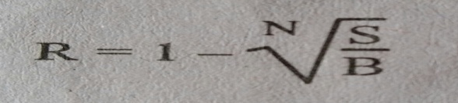
Where R= rate of depreciation
N =estimated life of asset
S=salvage value
B= original cost
This formula cannot be applied if the asset has no salvage value)
We can use the following formula to calculate depreciation of Matheson method
dk=B(1-R)^{k-1} (R)
Dk= B[1-(1-R)^{k}]
BVk=B(1-R)^{k}
Where, dk = depreciation amount of the particular year.
Dk= accumulated depreciated amount till the particular year.
BVk= book value of the particular year

Examples: a machine costing of Rs 4000 is estimated to have life of 10 years. Find d6, D6 and BV6, if R=20% and there is no salvage value by using Matheson method. Calculate form both table and formula method.
ADVANTAGES
- High amount of depreciation for earlier years of assets and as assets getting old, depreciation goes on diminishing is more scientific.
- It is suitable for assets having long life such as building, plant and machinery, etc.
- It is recognized by income tax authorities.
Disadvantages
- It is difficult to decide the rate of deprecation if salvage value is not given.
- The book value of asset cannot be reduced to nil with this method.
- It is applicable only for long life assets.
- It ignores interest on capital invested in fixed assets.
- Sinking fund method
Sinking fund method of depreciation ensures that the full capital invested in a project is recovered at the end of projects life. This method provides fixed periodic changes (constant amount) at the end of each period that earns compound interest over the life of the asset and would be equal to the original cost of asset. According to this method, the book value of asset decreases at increasing rate with respect to the life of the asset.
Let, I= initial/original cost,
S=salvage value, N=- life of asset, i=compound interest rate, A= annual equivalent amount
BVk= Book value at the end of year K
To find fixed annual equivalent amout
I-S
Fixed Depreciation = ---------------------
FvifAi%nyear
To find net depreciation charges in the year K
dk=Annual fixed depreciation x(Fvif,i%K-1)
To find book value at the end of year/ period K
BVk= I-[(Annual fixed dep. x(Fvifa,i%,K)]
Example: compute the depreciation charge and book value of each year by using sinking fund method with following information. Initial cost of asset = Rs, 100000, Salvage value = Rs 20000
Life of the assets =8 years i=12%
Solution: Calculation of annual fixed depreciation amount
I-S 100000-20000
Fixed Depreciation = --------------------- = ------------------------------- = 6504.22
FvifAi%nyear FvifA12%8yrs
Year | Beg. book value | Fixed dep. | Factor (1+i)^{k-1} | Net depreciation | Ending book value
1 | 100000 | 6504 | 1 | 6504 | 93496
2 |  | 6504 | 1.12 | 7284.48 | 86211.52
3 |  | 6504 |  | 8158.62 | 78052.90
4 |  | 6504 |  | 9137.65 | 68915.25
5 |  | 6504 |  | 10234.17 | 58681.08
6 |  | 6504 |  | 11462.27 | 47218.81
7 |  | 6504 |  | 12837.74 | 34381.07
8 |  | 6504 |  | 14378.27 | 20002.80
- Sum of the year digit SOYD method
Under this method, depreciation per annum is calculated on the basis of proportion of total number of estimated life years of an asset. This method results larger depreciation charges during the beginning years of asset and smaller depreciation charges as asset getting old ie as the asset nears the end of its estimated life. According to this method, per year depreciation charge is calculated from the ratio of the sum of the year digit for the total useful life and remaining useful life at the beginning of particular year.
SOYD= sum of individual years
DEPRECIAITON = I-Sx (Remaining life divided by SOYD)
Where I = initial investment
S= salvage value
Example:
A machine having a cost of Rs 36000 and estimated salvage value at the end of fifth year is Rs 6000. Calculate depreciation charges per annum under sum of year digit method.
Solution: I= Rs 36000, S= Rs 6000, N= 5 years
Sum of the year digit = 5+4+3+2+1=15
Proportion of year = 5:4:3:2:1
Depreciation charges for particular year will be as follow.
Year | Beg. Book value | SOYD Depreciation (I-S) (rem. Year/SOYD) | Ending book value
1 | 36000 | (36000-6000)x5/15=10000 | 26000
2 | 26000 | (36000-6000)x4/15=8000 | 18000
3 | 18000 | (36000-6000)x3/15=6000 | 12000
4 | 12000 | (36000-6000)x2/15=4000 | 8000
5 | 8000 | (36000-6000)x1/15=2000 | 6000
- Double rate declining balance method
According to this method, depreciation rate will be calculated under straight line method and multiply it by 2. Then the amount of depreciation is calculated by adopting declining balance method, so as to bring down the book value of the asset to its salvage value
Hence, Depreciation rate R = 1/Nx2
Example: consider the following accounting information for a computer system.
Initial cost of asset = Rs 10000
Useful life = 5 years
Compute the annual depreciation amount and resulting book value by using double rate declining balance method

- Service output method (unit of production method)
All the depreciation methods discussed above are based on time or year. But if the decrease in value of any asset is based on total working hour or production unit, then it is called service output method or unit of production method. This method gives equal depreciation charge for each unit of output or working hour regardless of the lapse of time involves. Depreciation rate per unit of output/working hour
(R)= I –S/ total working hour or production unit
Where, I = initial investment, S = Salvage Value
Example: a machine costing of Rs 50000 is estimated to have Rs 10000 salvage value when replaced after 30000 hours of used. Find its depreciation rate per hour of use and book value after 10000 hours of operation.
Solution: given, I= 50000, S= Rs 10000, total working hour = 30000
Depreciation rate per hour of use R = I –S/ total working hour
= (50000-10000)/30000 hours = Rs 1.3333
Depreciation amount after using 10000 hours = 10000 hours x rate per hour
= 10000x1.3333= Rs 13333
Book value after working 10000 hours = Rs 50000-13333= Rs. 36667
PU 2017: A company has purchased an equipment whose first cost is Rs 100000 with an estimated life of 8 years. The estimated salvage value of the equipment at the end of its lifetime is Rs 20000. Determine the depreciation using
a. Double declining method
b. Sum of the Year digit method
PU 2024 fall, What are the causes of depreciation? If a machine costing Rs 200000 is purchased by expecting salvage value of Rs 50000 at the end of 6th year. Calculate depreciation amount and book value each year by
- SOYD Depreciation method
- Declining balance method
- Straight line plus average interest method / switching method
Because the declining balance method never reaches book values of assets to zero, it is permissible to switch from this method to the straight-line method so that an assets book value will become to zero. Therefore, it is called straight line plus average interest method. In another words, it is called declining balance with switchover to straight line methods. According to this method, the switchover occurs in the year where a larger or equal depreciation amount is obtained from the straight-line method in comparison to deckling balance method.
Example
Consider the following information for a machine operation system
Initial cost = Rs 4000 Useful life = 10 years Salvage value = 0
Depreciation rate = 20 %
Compute the annual depreciation amount and book values by using straight line plus average interest method.
Solution
Given
B = Rs 4000 N = 10 years S = 0
Switchover form 20 % declining balance to straight line method.
Year (k) | Beginning book value | 20% declining balance method |  | Straight line method | Dep amount selected
1 | 4000 | 800 | > | 400 | 800
2 | 3200 | 640 | > | 355.56 | 640
3 | 2560 | 512 | > | 320 | 512
4 | 2048 | 409.6 | > | 292.57 | 409.6
5 | 1638.4 | 327.68 | > | 273.07 | 262.14
6 | 1310.72 | 262.14 | = | 262.14 | 262.14(swithch)
7 | 1048.58 | 209.72 | < | 262.14 | 262.14
8 | 786.44 | 167.77 | < | 262.14 | 262.14
9 | 524.30 | 134.22 | < | 262.14 | 262.14
10 | 262.16 | 107.37 | < | 262.14 | 262.14
Total |  | 3570.5
- The Modified Accelerated Cost Recovery System (MACRS)
The Modified Accelerated Cost Recovery System (MACRS) is the primary depreciation method used for tax purposes in the United States. It allows businesses to recover the cost of tangible assets (e.g., machinery, vehicles, equipment) over a specified recovery period through annual tax deductions.
MACRS is the principal method for computing depreciation in engineering projects. Under MACRS, the, SV_{N} is defined to be zero and useful life estimates are not used directly in calculating depreciation amount. The MACRS scheme includes eight categories of assets with lives of 3, 5, 7, 10, 15, 20, 27.5, and 398 years.
- Short lived assets like plastic products depreciated over 3 years by using 200% DB and then switching to SL method.
- Computer, automobile and light trucks are written off 5 years by using 200% DB and then switching to SL method.
- Most types of manufacturing equipment, office furniture, and fixtures are depreciated over 7 to 10 years by using 200% DB and followed by a switch to SL method.
- Sewage (drain) treatment plants and telephone distribution plants are written off over 15 years by using 150% DB and ten switching to SL method.
- Electrical power plants are written off 20 years by using 150% DB and then switching to SL method.
- Residential rental properties are written off over 27.5 years by SL method.
- Nonresidential real estate (commercial buildings) including elevators and escalators is written off by the SL method over 39 years.
A half year time convention is used in MACRS depreciation calculation that means all assets placed in service before the middle of this year. Hence, a half years depreciation being taken in the first year, a full year’s depreciation is allowed in each of the remaining years and a half years depreciation is taken in the year following the end of the recovery period. A half year of depreciation is also allowed for the year in which property is disposed any time after the end of the recovery period (useful life).
Example
A taxpayer wants to place in service of Rs 10000 asset that is assigned to the 5 year class. Compute the MACRS % and depreciation amount for the asset.
Solution
Given
Life of asset = 5 years
Cost of asset = Rs 10000
Salvage value = 0
Straight line rate = 1/Nx100 = 1/5x100= 20%
Declining balance rate = R/N= 200%/5 = 40%
For 5 years life R = 200%, according to IRS guidelines
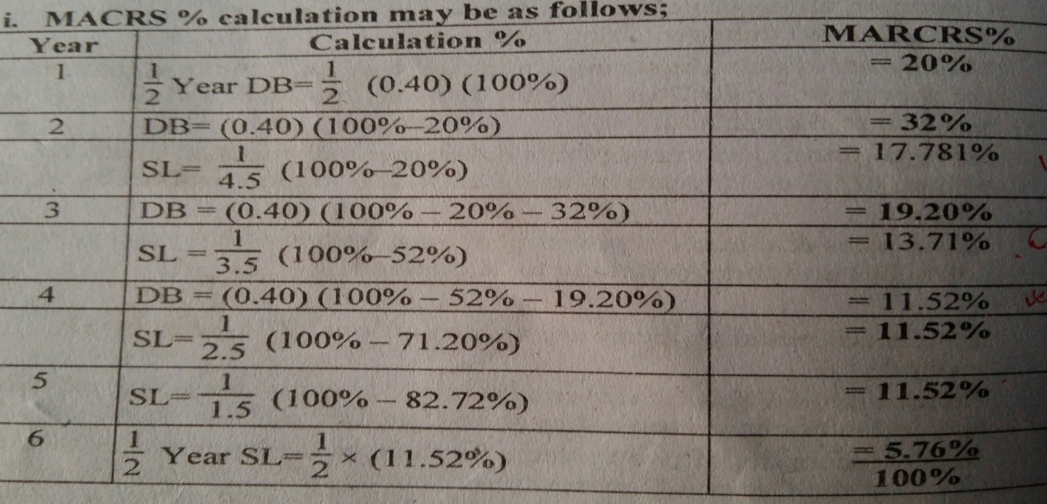
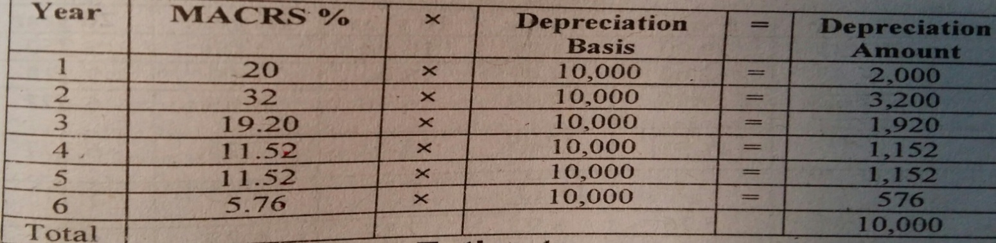

Depletion
Depletion is a gradual reduction of the stock or value of natural deposits like minerals, gas and oil, timber etc. when natural resources are being consumed or used in producing goods and services, the term depletion is used to indicate the decrease in value of the resource base that has occurred.
There is a difference in the manner in which the amounts recovered through depletion and depreciation. Depleting asset losses its value by actually being removed and sold, but depreciable asset losses its value through wear and tear in the manufacture of goods to be sold .Therefore, in the case of minerals and other natural resource business, money recovered through the depletion charge is likely to be used in the exploration and development of delectable assets. But, in the case of manufacturing or other business where depreciation occurs, the amounts charged for depreciation expense are reinvested for new equipment so that the business may continue in operation.
The cost method is the general rule for calculating a depletion deduction. It is expressed as,
Depletion deduction = (cost of property x number of units sold during year)/ number of units in property
Example
A zinc company bought on ore bearing land in January 2009 for Rs. 2000000. The recoverable resources in the mine were estimated to be 500000 tons.
- If 50000 tons of ore were mined and sold during the year, what was the depletion charge for 2009?
- Suppose at the end of 2009, the reserves were re valued and found to be only 400000 tons. If 50000 tons of ore were mined and sold in during 2010, what is the depletion charge for 2010?
Solution
- Depletion charge for 2009= (2000000x50000)/500000 = Rs 200000
Adjusted cost of property at the beginning of 2010 would be
Rs. 2000000—200000= Rs 1800000
- Depletion charge for 2010
Adjusted cost of property at the beginning of 2010 would be
Rs 2000000- Rs 200000 = Rs 1800000
Depletion charge for 2010 = (Rs 1800000 x 50000)/400000
=Rs 225000

